Grazing
Impress your guess with a beautiful hand-crafted grazing platter loaded with delicious mouth-watering produce, not only will a grazing platter keep you satisfied for hours, but it will also keep you out of the kitchen!!

The team at JA Catering & Events create each grazing platter to the needs of their client – not one grazing platter is ever the same!

We can create all different styles and sizes, depending on your needs.
Our antipasto boards or tables contain a wide and tasteful selection of deli meats, hard and soft cheeses, grilled and marinated vegetables, fresh and dried fruits, nuts, crackers, jams and of course CHOCOLATE!!!

“OUR AIM”
Is to deliver your vision, so all you need to do, is GRAZE!!!!!

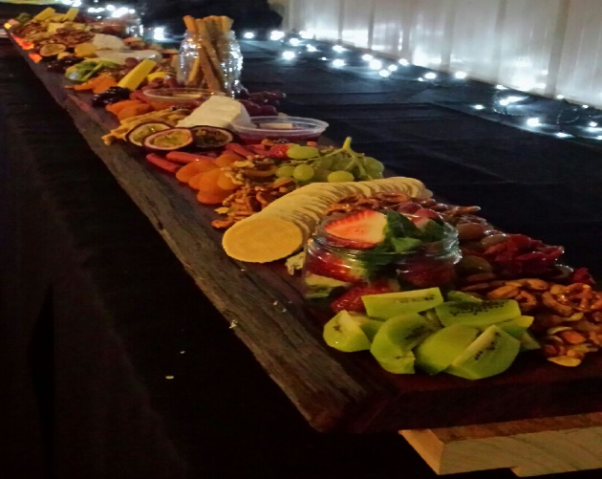

Below is an example of what you could/would find on one of our grazing platters. We ask that you have a read over and jot down things you like, or like the sound of, so then we can get an idea of what you have in mind. We have attached a page at the back where you can write down your list of favourites.

FRUIT & VEGETABLE (seasonal)
Oranges, Green Apples, Red Apples, Mandarins, Kiwi Fruit, Pineapple, Mango, Strawberries, Blueberries, Raspberries, Red Grapes, Green Grapes, Purple Grapes, Passionfruit, Banana, Pear, Pomegranates, Watermelon, Cantaloupe, Honeydew, Apricots, Plums, Cherries, Carrots, Mixed Lettuce Leaves, Celery, Cherry Tomatoes, Capsicum
DRIED FRUIT AND NUTS
Cashew, Walnut, Almonds, Macadamias, Pecans, Pistachios, Figs, Apple, Pear, Apricot
CHEESE
Bocconcini, Marinated Bocconcini, Feta, Cream Cheese, Brie, Camembert, Colby, Aged Cheddar, Tasty, Maasdam, Edam, Dutch Smoked, Vintage Cheddar, Blue Veined, Gorgonzola Blue
BREAD/CRACKERS
Sliced Baguette Toasted and Untoasted, Whole Grain Crackers, Water Crackers, Rice Crackers, Cheeseboard Crackers, Fine Wafer Crispbreads, Grissini Sticks
CHARGRILLED
Artichokes, Capsicums, Eggplant, Zucchini, Cherry Tomato Semi Dried, Pepper Belles Filled, Semi Dried Tomatoes
CONDIMENTS
Red Onion and Thyme Jam, Chilli Relishes, Tomato Relish, Moroccan Beetroot Relish, Tomato Chutney, Fruit Chutney, Mango Chutney, Quince Paste, Hummus, Tzatziki, Basil Pesto, Spicy Capsicum Pesto, Duck, Honey and Cumin Pâté, Chicken and Smoky Garlic Pâté
SWEET AND SALTY
Stuffed Pepper Balls, Marinated Mixed Olives, Olives, Pitted Kalamata Olives, Capers, Pickled Onions, Caramelized Onions, Gherkins, Candied Nuts……and CHOCOLATE!
MEATS
Salmon, Cured Meats, Prosciutto, Salami, Twiggy Sticks, Oysters, Mussels, Prawns or Shaved Ham, Roast Beef, Cabanossi
CHOCOLATE
Ferrero Rocher, Chocolate Raspberry Balls in White or Milk Chocolate, Chocolate Coated Licorice, After Dinner Mints, Lindt Chocolate Balls…..or even Chocolate Coated Jelly Snakes!!!
Please Note:
The team at JA Catering & Events are always happy to tailor any of our menu items to accommodate further dietary requirements where possible.
For pricing and available packages please see next page.
PRICES AND PACKAGES
Consider setting up a grazing table to greet your guests to your venue before enjoying the main menu or perhaps have more than one table and make it the main event? Our grazing catering packages include everything you will need other than your set up/service staff or delivery charges, which we add on once we know exactly what you are after and the number of guests you wish to cater for. This way you only pay for exactly what you need.
Tables
Staff Member to arrive and set up 1-2 hours prior to guests arrival You provide the grazing table or board, and your own equipment to cater for your chosen grazing menu, along with plates, forks and napkins OR we the team at JA Catering and Events can provide you with the works!! The Board, Plates, Napkins, Forks etc.
Please contact JA Catering and Events to discuss prices, sizes and options available for grazing tables.
Delivery Charges Apply Outside 20km of Ballarat

Grazing Platter
Size and Price
Square 11” $ 55.00 Serves 2-5 people^
Square 12” $ 65.00 Serves 5-8 people^
Square 13” $ 75.00 Serves 10-12 people^
Square 16” $100.00 Serves 12-15 people^
Round 16” $ 90.00 Serves 15 people approximately
Rectangle 14”X 18” $120.00 Serves 15-20 people^
^ Approximately Serves
Platters will be made up of a variety of the following items;
- Meats Kabana, Salami, Chorizo, Ham, Prosciutto
- Cheese Camembert, Brie, Tasty, Cheddar, Blue Cheese, Edam, Feta
- Antipasto Mix Olives, Sun Dried Tomatoes
- Seasonal Fruits Strawberries, Grapes, Cherries, Kiwi, Dried Apricots/Apples/Pear
- Crackers and Breads Wafer, Crispbread, Mini Toast, Grissini, Lavash, Turkish
- Additional Extras Almonds, Walnuts, Figs, Dates, Raisins, Chocolate
Free delivery within 20km of Ballarat if required or collection is available from our premises in Delacombe, Ballarat Victoria. If you require delivery outside of Ballarat, please call for a delivery price.
*Platters will be required to be wrapped and boxed up for delivery or collection, to secure goods until arrives at location

